Bible life messages
The Evidence of Your Salvation
I John 4:7-15

₁ How do you know if God has saved you? ₂
You are saved by His grace. ₃ When you respond to that grace by repenting of your sins and by being baptized, God will indwell you with His Holy Spirit. That’s God’s promise!
But what is the evidence that salvation is really happening?
Some would say you know from the Pentecostal Holiness experience of speaking in tongues. Others might say it is the sudden desire to know the Lord, study His Bible and worship Him. ₄
Our scripture today may help. It is from First John, chapter 4, verses 7 through 15. Dear friends, let us love one another, for love comes from God. Everyone who loves has been born of God and knows God. Whoever does not love does not know God, because God is love. This is how God showed his love among us: He sent his one and only Son into the world that we might live through him. ₅
This is love: not that we loved God, but that he loved us and sent his Son as an atoning sacrifice for our sins. Dear friends, since God so loved us, we also ought to love one another. No one has ever seen God; but if we love one another, God lives in us and his love is made complete in us. ₆
We know that we live in him and he in us, because he has given us of his Spirit. And we have seen and testify that the Father has sent his Son to be the Savior of the world. If anyone acknowledges that Jesus is the Son of God, God lives in him and he in God. ₇
God’s word says here in verse 11, ₈ it’s the desire to love the Lord by loving His people! ₉
Philip Bliss, writing in his old gospel song many of us grew up singing, put it this way.
----------
“Oh, How I Love Jesus.”
I am so glad that our Father in heaven
Tells of His love in the book He has given;
Wonderful things in the Bible I see --
This is the dearest, that Jesus loves me!
Though I forget Him and wander away,
Still He does love me wherever I stray;
Back to His dear loving arms would I flee
When I remember that Jesus loves me!
He realized how short his human love came in contrast to God’s love for him! ₁₀
So, where does this love come from and what makes it an evidence of your salvation? ₁₁
I. Where Does Love Come From? - v7-12
Where does love come from? ₁₂
Love begins with God! Verses 7 and 8 explain, Dear friends, let us love one another, for love comes from God. Everyone who loves has been born of God and knows God. Whoever does not love does not know God, because God is love. ₁₃
This explains why God created us. With all your heartbreak, your rebellion and your lack of response to His love, why bother! ₁₄ Because love, to be love, needs an object. So, He created you! ₁₅
This explains why God gave you freewill. Love isn’t worth much unless it is freely given. ₁₆ God created evil, the very opposite of Himself, so you could have a clear-cut choice. ₁₇
This also explains why God has such a personal interest in His creation. ₁₈
Some of the founding fathers of the United States, concluding from some of their writings, were Deists. Briefly, this position states, that they believed in a creator God. After Creation, God then let us alone to shift for ourselves.
This position was aptly demonstrated in the movie several years ago called, “Oh, God!” George Burns, who plays God, at the end of the movie, finally just goes off into the sunset to play with the animals! ₁₉
But the God of the Bible prefers to work in and through your life! ₂₀
This explains why God sent His Only Son to the cross! ₂₁
Without love, God could have left you to face the consequences of your rebellion and disobedience, death! ₂₂
With love, God Himself paid the price for your sins so you could have eternal and abundant life! ₂₃
Love was made known through Lord Jesus! Verses 9 and 10 continue, This is how God showed his love among us: He sent his one and only Son into the world that we might live through him. This is love: not that we loved God, but that he loved us and sent his Son as an atoning sacrifice for our sins. ₂₄
The Lord was the bringer of real life. Are you just existing today without real purpose in your life? If your purpose is not loving God, then it’s not the purpose He intended for you to have. If you really want to come alive, switch the purpose in your life to loving Him! ₂₅
The Lord is the restorer of your lost relationship with God. God loved you first! Romans, chapter 5, verse 8, But God demonstrates his own love for us in this: While we were still sinners, Christ died for us. ₂₆
The phrase atoning sacrifice is a technical term in the original language. It literally meant “the Mercy Seat”. In ancient Jewish ceremony the mercy seat was the solid gold lid that covered the Ark of the Covenant.
On Yom Kippur, the Day of Atonement, and the most sacred ceremony of the year, the High Priest would enter the most sacred place in the Jewish temple and sprinkle animal blood on this gold cover. This ceremony postponed God’s judgment of the Jewish nation’s sins and the individual sins for every confessing and repentant Jew.
Bible translations of this phrase are “expiation” or “propitiation”. I’m sure you all know what those 50 cent words mean. Right?
What this scripture is saying is that Lord Jesus provides the forgiveness of sins for every confessing and repentant person. The big difference here is that the Jewish atonement had to be repeated each year. Lord Jesus’ death on the cross only happened once!
The fellowship with God that was lost in the garden was restored by the cross! ₂₇
Love is displayed to the world through us! Verse 12 continues, No one has ever seen God; but if we love one another, God lives in us and his love is made complete in us. ₂₈
Love is how God lives in us. The word lives in means to abide, remain or dwell. ₂₉
Made complete means to make perfect or become mature. As you express love to others as a person through whom God lives, your love continues to grow to maturity. This makes the world sit up and take notice! ₃₀
So . . .
II. How Does Love Become the
Evidence of Your Salvation? - v13-15
How does love become the evidence of your salvation? ₃₁
Love comes “of His Spirit”. Verse 13, We know that we live in him and he in us, because he has given us of his Spirit. ₃₂
Romans, chapter 5, verse 5 says, God has poured out his love into our hearts by the Holy Spirit, whom he has given us. ₃₃
Love is the first Fruit of the Spirit! ₃₄ Also the word know in verse 13 means to know because of your personal experience. ₃₅ So, if you have this fruit of the Spirit you can know by experience that you are remaining in Him and God is remaining in you! ₃₆
In our final verses for today, verse 14 and 15, Love becomes the expression of an active faith! And we have seen and testify that the Father has sent his Son to be the Savior of the world. If anyone acknowledges that Jesus is the Son of God, God lives in him and he in God. ₃₇
Saving faith is trusting Lord Jesus as the Son of God and your Savior.
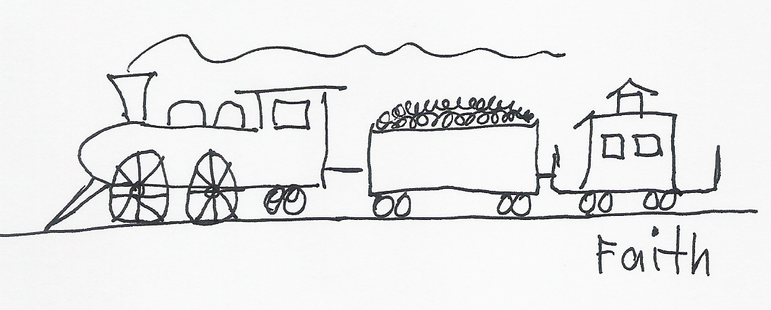

₃₈ Putting your faith into a verbal witness, like the Good Confession, makes it alive!
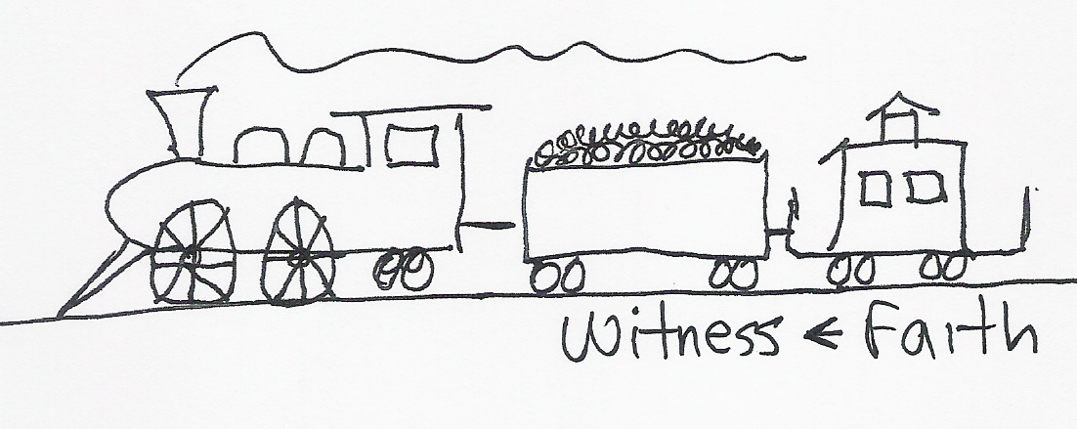
₃₉ Putting your confession, or verbal witness, into an active love gives it power!
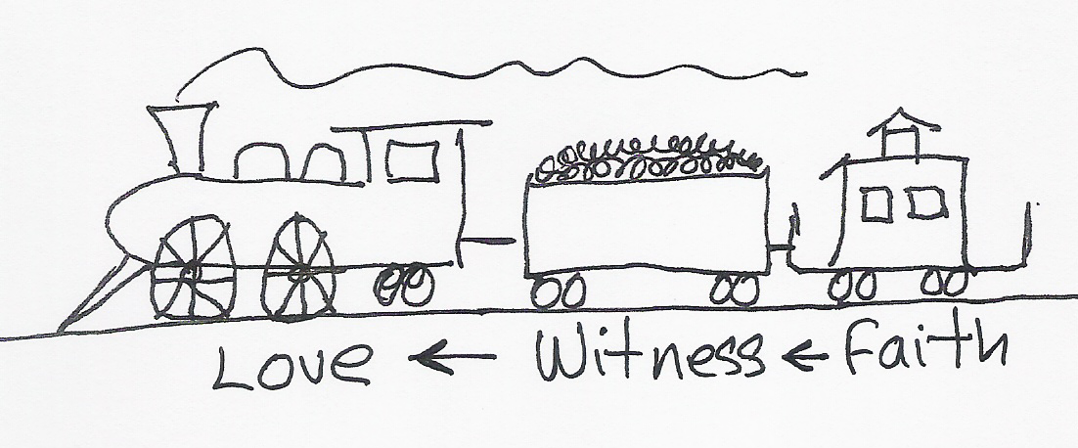
₄₀ James, chapter 2, verses 14 through 18 puts it this way, What good is it, my brothers, if a man claims to have faith but has no deeds? Can such faith save him? Suppose a brother or sister is without clothes and daily food. If one of you says to him, “Go, I wish you well; keep warm and well fed,” but does nothing about his physical needs, what good is it? In the same way, faith by itself, if it is not accompanied by action, is dead. But someone will say, “You have faith; I have deeds.” Show me your faith without deeds, and I will show you my faith by what I do. ₄₁
So, love becomes the evidence of your salvation when it is coupled to an active faith!

http://biblelifemessages.org/

Ephesians 2:8-9 - For it is by grace you have been saved, through faith — and this not from yourselves, it is the gift of God — not by works, so that no one can boast.
Acts 2:38 - Peter replied, “Repent and be baptized, every one of you, in the name of Jesus Christ for the forgiveness of your sins. And you will receive the gift of the Holy Spirit.
I John 4:4-9.
I John 4:10-12.
I John 4: 13-15.
I John 4:11 - Dear friends, since God so loved us, we also ought to love one another.
Romans 6:23 - For the wages of sin is death.
John 3:16 - For God so loved the world that he gave his one and only Son, that whoever believes in him shall not perish but have eternal life.
I John 4:9 - He sent his one and only Son into the world that we might live through him.
ἱλασμός.
μένω.
τελειόω.
Galatians 5:22 - But the fruit of the Spirit is love, joy, peace, patience, kindness, goodness, faithfulness, gentleness and self-control. Against such things there is no law.
γινώσκω.

