Bible life messages
What a Soldier of Christ Needs to Know
Ephesians 6:10-20

₁ What does a soldier of Christ need to know?
In the late 1980’s an author by the name of Frank Peretti published a couple of books. This Present Darkness was published in 1988 and Piercing the Darkness arrived in bookstores in 1989. Even though they were novels they created a renewed interest in the Christian doctrine of Spiritual Warfare.
Christian books on the subject began to flourish. Preachers throughout the world began preaching sermons on the topic and Bible studies spread rapidly. Spiritual warfare was a very popular subject across all denominational lines for about ten years. The fad died down and we do not hear much about it now except, possibly, in Pentecostal/Holiness churches.
But the teaching is still biblical and true. Christians need to be prepared biblically to go into spiritual battle.
In 2002 Operation Enduring Freedom occurred. In February 2003, my Army Reserve unit mobilized from San Jose, California to Fort Leonard Wood, Missouri. Our mission, as an Army Garrison Support Unit, was to turn the major military training installation into a regional mobilization center.
National Guard units from all over the Midwest converged at Fort Leonard Wood. Our unit processed the personnel, equipped individuals and their units and provided them collective training. By the time they left the installation they had the best equipment and the finest training available so that they could merge with the active-duty units in theater. Because our troops were the best equipped and trained in the world the victorious invasion of Iraq lasted only 21 days!
You, as soldiers of the Lord, also need to be equipped and trained for the spiritual battles that you face. ₂
There are three things an army needs to know to have victory on the battlefield. They need to know the enemy, the location and their own war fighting doctrine. ₃
They need to know their enemy, his doctrine, his weaponry and his training. ₄
They need to know the location, the battlefield and the terrain. ₅
They need to know their own doctrine; how they can effectively fight as a team, what their mission is, their equipment and how to use it. ₆
Our scripture today informs us about our enemy and what we can use to defeat him. ₇
Ephesians, chapter 6, verses 10 through 20 say, Finally, be strong in the Lord and in his mighty power. Put on the full armor of God so that you can take your stand against the devil’s schemes. For our struggle is not against flesh and blood, but against the rulers, against the authorities, against the powers of this dark world and against the spiritual forces of evil in the heavenly realms. ₈
Therefore put on the full armor of God, so that when the day of evil comes, you may be able to stand your ground, and after you have done everything, to stand. Stand firm then, with the belt of truth buckled around your waist, with the breastplate of righteousness in place, and with your feet fitted with the readiness that comes from the gospel of peace. In addition to all this, take up the shield of faith, with which you can extinguish all the flaming arrows of the evil one. ₉
Take the helmet of salvation and the sword of the Spirit, which is the word of God. And pray in the Spirit on all occasions with all kinds of prayers and requests. With this in mind, be alert and always keep on praying for all the saints. Pray also for me, that whenever I open my mouth, words may be given me so that I will fearlessly make known the mystery of the gospel, for which I am an ambassador in chains. Pray that I may declare it fearlessly, as I should. ₁₀
In spiritual warfare the first question that needs to be answered is . . .
I. Who is the Enemy? - v11-12
Who is the enemy? ₁₁
Why is it important to know the enemy? Because you could lose the war if you don’t!
In the movie “Patton”, in North Africa, the combatants were General Patton and Field Marshall Rommel. The German high command kept getting briefings about who Patton was and how he operated. Patton kept Field Marshall Rommel’s book of armored tactics setting on his nightstand. Each combat leader attempted to know the other as thoroughly as he could. ₁₂
Your spiritual enemy is the devil and his demons. ₁₃
Lord Jesus called the devil the enemy. He is a fallen angel (a spiritual being) with over 6000 years of experience. You are no match for him on your own. He has spiritual power! ₁₄
The devil, Satan, fell from heaven, ₁₅ and has a kingdom. ₁₆
Verse 11 tells us that Satan, also, has a mission. Put on the full armor of God so that you can take your stand against the devil’s schemes. ₁₇ His purpose is to enslave you into his kingdom. But his only effective weapon against you is temptation. ₁₈
He uses schemes. In the original language this word means strategies, deceitful methods, craftiness. The King James translation calls it “wiles”. The Apostle Paul stated it this way, The god of this age has blinded the minds of unbelievers, so that they cannot see the light of the gospel of the glory of Christ, who is the image of God. ₁₉
Then, in verse 12, we find that his army consists of spiritual beings called demons. For our struggle is not against flesh and blood, but against the rulers, against the authorities, against the powers of this dark world and against the spiritual forces of evil in the heavenly realms. ₂₀
We don’t fight against flesh and blood. ₂₁ Demons are rulers and authorities described as powers of this dark world and spiritual forces of evil in the heavenly realms - the spiritual world! ₂₂ Our struggle, however, is not with the demons, remember, but with the temptations they provide! ₂₃
Also, remember that they will be eventually thrown into the lake of burning sulfur! ₂₄
In spiritual warfare the next question that needs to be answered is . . .
II. What is the Location - the Battlefield?
What is the location, the battlefield? ₂₅
As we mentioned before, the battlefield is your mind. Romans, chapter 12, verse 2, Do not conform any longer to the pattern of this world, but be transformed by the renewing of your mind. ₂₆
How do we know that? In Luke, chapter 4, we have recorded for us major temptations the Lord faced. After His baptism he went into the desert and for forty days He was tempted by the devil. He successfully overcame these temptations by quoting scripture that He had memorized. ₂₇
You are tempted in your mind. James, chapter 1, verse 14, ... each one is tempted when, by his own evil desire, he is dragged away and enticed. ₂₈
The final question this passage answers for us is . . .
III. What Will Make You Victorious? - v10 & 13-20
What will make you victorious? ₂₉ What must you do with what you have been given? Verse 13 says, Therefore put on the full armor of God . . . ₃₀ Put on means to lift up and carry; to bring it along. ₃₁ The phrase take up in verse 16 is the same word! ₃₂
Now, in verses 14 through 17, God gives you all you need for protection! ₃₃
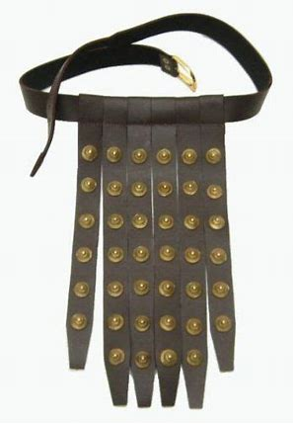
In verse 14 you were issued the belt. ₃₄ A Roman soldier was issued a thick belt to hold his toga together and holster his sword. ₃₅
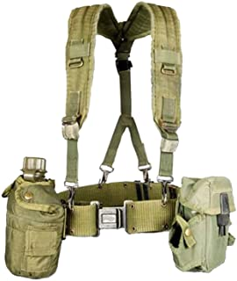
A modern soldier is issued an LBE consisting of a strap around his shoulders attached to a thick belt. This assortment contains ammunition, canteens, a first aid pack, a small arms weapon and a flashlight. ₃₆
Your spiritual belt is truth so you can move freely and decisively when temptation arrives. You must know the truth in the Bible to be a truthful, honest person. This truth will set you free! ₃₇
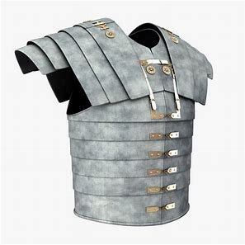
Verse 14 also says you were issued a breastplate. This is a reference to Isaiah, chapter 59, verse 17, He put on righteousness as his breastplate, and the helmet of salvation on his head . . . ₃₈ A breastplate protected a soldier’s chest and mid-section from arrows his shield might miss. ₃₉
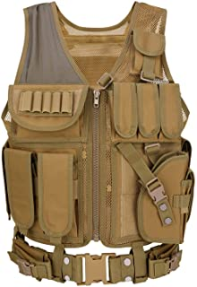
A modern soldier is issued a flak jacket to protect him from shrapnel and stray bullets. ₄₀
Your spiritual breastplate is righteousness, doing the right thing before God and man. Accusations and slander cannot penetrate your life because righteousness proves them to be lies. Ancient documents tell us Christians were seldom persecuted after 200 AD because of popular opinion. They were noted for not doing wrong things! ₄₁
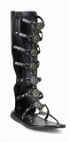
In verse 15 you are issued shoes. ₄₂ The sandals a Roman soldier wore were laced all the way up his leg to secure them to his feet. ₄₃
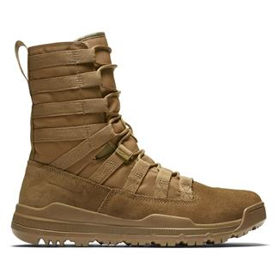
A modern soldier’s combat boots are designed to protect his feet from the environment. He is ready to go into combat when his boots are securely laced to his legs! ₄₄
Your boots are the gospel message. They make you ready to go into spiritual combat. ₄₅
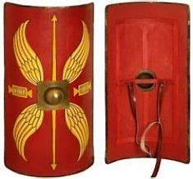
Verse 16 states that you are issued a shield. In addition to all this, take up the shield of faith, with which you can extinguish all the flaming arrows of the evil one. ₄₆ A roman soldier’s battle shield was four feet long with two sections of wood and a section of iron. A flaming arrow could be extinguished when it penetrated the first layer of soft wood. ₄₇
A strong faith in the Lord’s promises will extinguish Satan’s temptations hurled against it! ₄₈
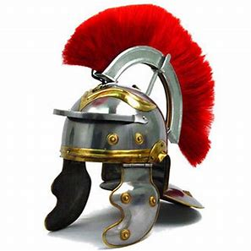
In verse 17 it says you are issued a helmet. ₄₉
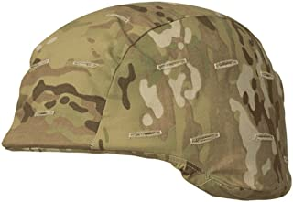
A modern soldier’s Kevlar helmet is designed with a light, extremely hard material to protect the head, ears and neck. The round design protected both the Roman and the modern soldiers from direct impact. Blows to the head glance off! ₅₀
Your spiritual helmet is your hope of salvation. Everything in this life is temporary. Eternity is permanent! Therefore you should be able to handle any temporary trials in this short life! ₅₁
Verse 17 says that God gives you all you need for the offense. He says, . . . and the sword of the Spirit, which is the word of God. ₅₂
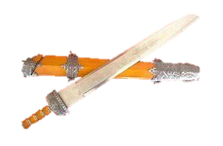
The Roman short sword was just a little longer than a modern Bowie knife. Other ancient countries used arrows and lances. Rome used them too. But Rome conquered the world with the short sword! ₅₃
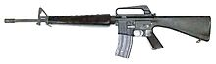
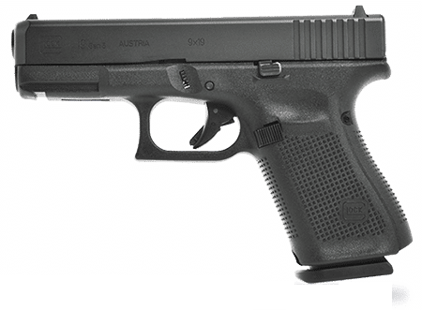
Although this will soon change, the modern soldier’s primary weapons are the M16-A2 and the M9. These are the most accurate and advanced individual fighting weapons in the world. ₅₄
Your primary offensive spiritual weapon is the word of God. ₅₅ Hebrews, chapter 4, verse 12, describes this sword. For the word of God is living and active. Sharper than any double-edged sword, it penetrates even to dividing soul and spirit, joints and marrow; it judges the thoughts and attitudes of the heart. ₅₆ It is to comfort and to encourage God’s people. ₅₇ It is to convict hearts and to win people to a personal relationship with the Lord.
Matthew, chapter 16, verse 18 says, And I tell you that you are Peter, and on this rock I will build my church, and the gates of Hades will not overcome it. In the original language, this verse pictures the church like an advancing Roman army. When properly equipped and trained, nothing can stand in it’s way! ₅₈
How do you get the strength you need for victory? Verses 18 through 20 tell us. And pray in the Spirit on all occasions with all kinds of prayers and requests. With this in mind, be alert and always keep on praying for all the saints. Pray also for me, that whenever I open my mouth, words may be given me so that I will fearlessly make known the mystery of the gospel, for which I am an ambassador in chains. Pray that I may declare it fearlessly, as I should. ₅₉
The Romans had the best communication system of their day with their couriers. They were called “Evangelists”! They would run, or ride, hurriedly from the battlefield to bring the news of victory to the king. ₆₀
Our modern military has the best communication system in the world. I was stationed in Southern Germany during the Cold War. The Soviet forces-built hundreds of tanks which they planned to line up at the Fulda Gap in East Germany. The plan was to completely overwhelm our allied forces with the shear number of armored vehicles.
Their problem was the vehicles were mass produced so cheaply, in order to have vast numbers, that they only had radio receivers in those vehicles. It was only one-way communication. There was no way to tell their commanders about the changes happening on the battlefield. Our communication, however, could keep our commanders informed concerning every detail about enemy positions and tactics the moment the enemy executed them.
Here's another war story to illustrate the point. I was stationed one summer with the Calvary regiment at the National Training Center in Barstow, California. Our unit was the enemy force used to train our Army’s armored divisions. That summer the Infantry Division of the South Carolina National Guard arrived to do battle with us. They had the best “book” training and the most modern equipment in the world. We had obsolete World War II Sherman tanks and implemented soviet tactics.
For the first couple of weeks we whipped the socks off the Division because we were so well trained with our doctrine and equipment. Before they left, they started winning; but only after they put into practice what they had learned in their “books”.
The point here is, you are on the winning side when you learn God’s spiritual communication system and practice it. ₆₁ Verse 18 says you have prayer! And pray in the Spirit on all occasions with all kinds of prayers and requests. With this in mind, be alert and always keep on praying for all the saints. ₆₂
Your prayer must be consistent. First Thessalonians, chapter 5, verse 17 says to pray continually. ₆₃
Your prayer must be unselfish, for all the saints. ₆₄
Your prayer must be intense. Be alert, in verse 18, means to be awake, keep watch without sleeping. ₆₅
Your prayer must be for the right purpose. Verse 19 says, Pray also for me, that whenever I open my mouth, words may be given me so that I will fearlessly make known the mystery of the gospel. The apostle asked for prayer that he would have boldness of speech when presenting the gospel message. ₆₆
Pray as though you really mean it. That will give you power in your life!
What does a soldier of Christ need to know? Remember who the enemy is, Satan. Remember what the battlefield is, your mind and attitudes. Remember what will make you the victor, the right spiritual armor and sword. Remember what will give you the power to win, prayer!

http://biblelifemessages.org/

My chaplain team ministered to over 5000 soldiers during this time.
Ephesians 6:10-12.
Ephesians 6:13-16.
Ephesians 6: 17-20.
Matthew 13:39 - . . . the enemy who sows them is the devil.
Luke 10:18 - He replied, “I saw Satan fall like lightning from heaven. And, Milton, John, Paradise Lost.
Matthew 12:26 - If Satan drives out Satan, he is divided against himself. How then can his kingdom stand?
μεθοδεία.
II Corinthians 4:4.
Revelation 20:10 - And the devil, who deceived them, was thrown into the lake of burning sulfur, where the beast and the false prophet had been thrown.
Luke 4:1-13.
ἀναλαμβάνω.
Ephesians 6:16 - In addition to all this, take up the shield of faith.
Ephesians 6: 14 - Stand firm then, with the belt of truth buckled around your waist . . .
Ephesians 6:14 - . . . with the breastplate of righteousness in place . . .
Ephesians 6:15 - . . . and with your feet fitted with the readiness that comes from the gospel of peace.
Ephesians 6:16 - Take the helmet of salvation . . .
ἀγρυπνέω.

