Bible life messages
How to Receive a Right Relationship with God
Romans 3:21-26

₁ “Hey man, trust me!” Have you ever heard that before?
While stationed in Korea, I was walking down a main street in the Itaewon district of Seoul. This street, typical of one’s bordering major United States military installations, was lined with shops and drinking establishments catering to military personnel. It wasn’t long before I was approached by a young Korean man wearing several wrist watches on each of his arms.
“Would you like to buy a Rolex watch”, he said. “I’ll make you a real good deal.”
“Oh, are they genuine Rolex’s”, I asked (trying hard to keep a straight face).
“Oh, yes, genuine Rolex watches. Real cheap! Come to our shop right down this street”, he answered. “Real good deal, just for you the price is $18.50. Come!”
When I arrived at the “store”, it was just one room with watches hanging from the walls, from floor to ceiling. All of them were “genuine” Rolexes.
I thought of the novelty of owning a Rolex, genuine or not. After all, they were just $18.50! I bought one for me, my oldest two sons and my wife. It was a pretty good deal, right?
They only lasted a couple of years, but it was worth it, showing off our “genuine” treasures with the Rolex faceplates. ₂
“Hey man, trust me!” It’s like Crazy Charlie’s used car lot. “You like it, you can drive it away!” “You don’t need credit.” “You don’t need money.” Crazy Charlie could be an inmate at San Quentin, but he’s expecting you to “trust him”.
Have any of you had an unsolicited telephone call where the voice on the other end tried to sell you something? All she needed was your credit card information and you could be the proud owner of a valuable item real cheap. It’s a special offer; a “once in a lifetime deal”. Right!
With all of these “great deals” out there, ₃ who can you trust? ₄
Lord Jesus says, “Hey man, trust Me!” – and you can!
Notice our scripture passage today, ₅ But now a righteousness from God, apart from law, has been made known, to which the Law and the Prophets testify. This righteousness from God comes through faith in Jesus Christ to all who believe. There is no difference, for all have sinned and fall short of the glory of God, and are justified freely by his grace through the redemption that came by Christ Jesus. ₆
God presented him as a sacrifice of atonement, through faith in his blood. He did this to demonstrate his justice, because in his forbearance he had left the sins committed beforehand unpunished — he did it to demonstrate his justice at the present time, so as to be just and the one who justifies those who have faith in Jesus. ₇
I. You Can Be a Sinner Without Even Trying – v23
This might be hard to believe, but did you know that you can be a sinner without even trying. ₈
Everyone has sinned. That makes us all sinners. Again, notice verse 23, . . . for all have sinned and fall short of the glory of God . . .
Well how did this happen? Supposedly, what Adam and Eve did in the Garden of Eden when they rebelled against God’s instructions and ate the fruit, applies to us. The doctrine of Original Sin is taught in many churches. The classic argument to convince unbelievers that they are sinners is to tell them that this terrible condition they have was inherited. We simply inherited Adam and Eve’s sin of rebellion. That’s why we are all sinners.
But ₉ telling people about the Doctrine of Original Sin really doesn’t help them! ₁₀ How can you feel guilty about something someone else did thousands of years ago? ₁₁ How can you repent, a decision to change your personal conduct, based on something someone else did? ₁₂
Besides, Ezekiel, Chapter 18, verse 20, says, The soul who sins is the one who will die. The son will not share the guilt of the father, nor will the father share the guilt of the son. The righteousness of the righteous man will be credited to him, and the wickedness of the wicked will be charged against him. ₁₃
This verse tells us that you are personally guilty of sin! You have done it; in fact! Look at your life and think about what you have done that you knew was against God’s will. Think about it; and then fill in the blanks! ₁₄
The phrase “fall short” in verse 23, in the original language , means not to attain a certain level or goal. This phrase is in the present tense implying that falling short is happening continually in your life, probably a lot! So it shouldn’t be hard to discover that you, personally, are guilty of sin. You didn’t inherit Adam and Eve’s sin. You just follow after their rebellious example. ₁₅
How do you fall short? ₁₆ You fall short by not allowing God to truly rule within your heart. ₁₇ You fall short by conforming to the environment around you instead of God’s purposes. Romans, Chapter 12, verse 2 says, Do not conform any longer to the pattern of this world, but be transformed by the renewing of your mind. ₁₈
So, it’s easy to be a sinner. You can do it without even trying! ₁₉

II. You Can Become a Saint Without Even Trying – v22 & 24-26
Just like you can be a sinner without even trying, you can also become a saint without even trying. Our Bible passage continues, This righteousness from God comes through faith in Jesus Christ to all who believe . . . and are justified freely by his grace through the redemption that came by Christ Jesus. ₂₀
In fact, when you try to become a saint, you do it wrong! In verse 21 it reads, But now a righteousness from God, apart from law, has been made known, to which the Law and the Prophets testify. ₂₁ “Righteousness”, in this verse , means being right, having a right relationship. ₂₂ This is “apart from law”. You can’t get to heaven by trying to be good because you can’t be good enough. ₂₃
Here’s why. There is a gulf separating you and God. ₂₄
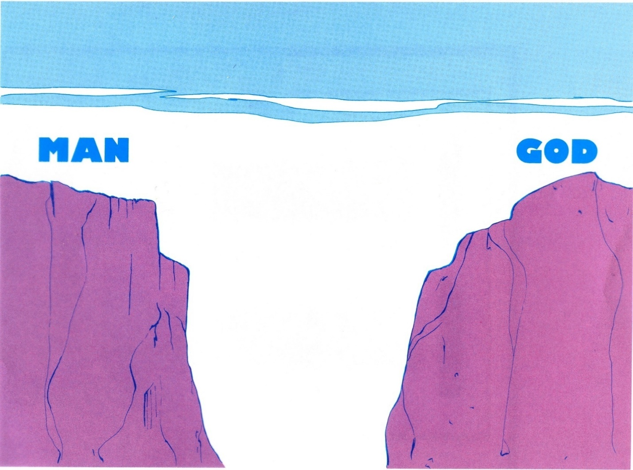
There is no way to get across to God by your own efforts. ₂₅
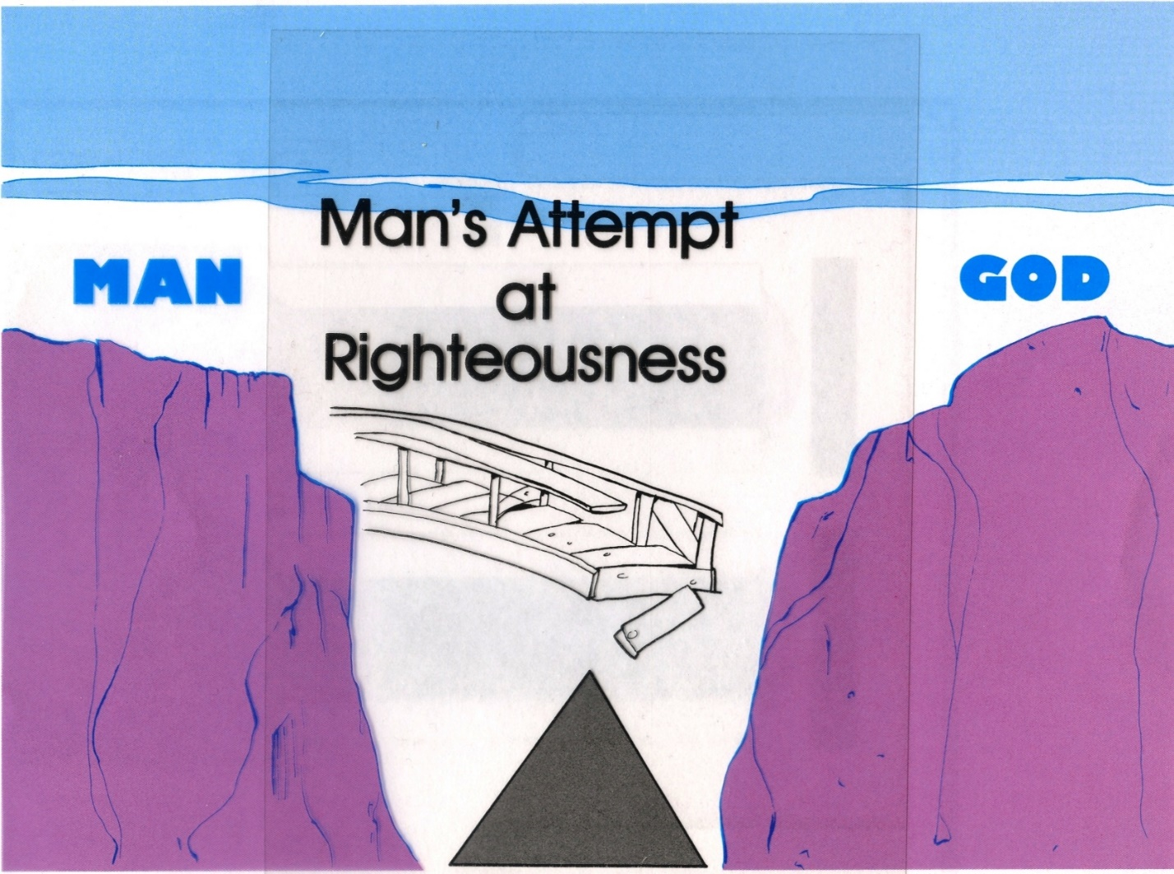

₂₆ Only by receiving what Lord Jesus did for you on the cross can you cross that gulf!
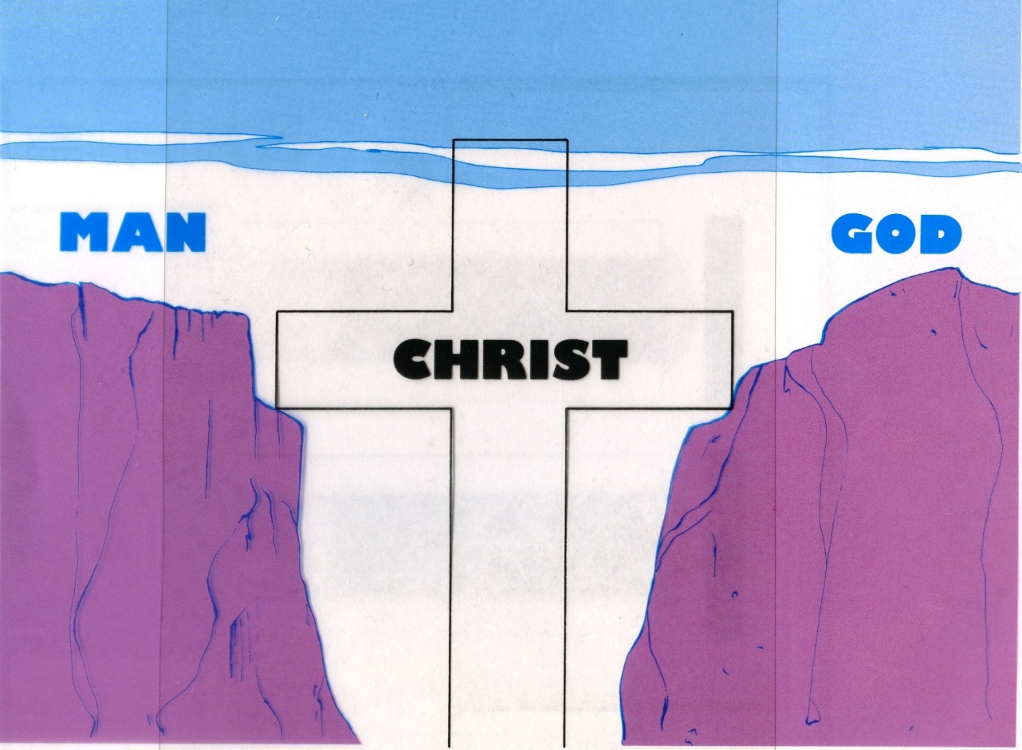
The right relationship to God, righteousness, comes only from trusting Lord Jesus. ₂₇ Verse 22 continues, This righteousness from God comes through faith in Jesus Christ to all who believe. ₂₈ The words “faith” and “belief” in the Bible, both actually mean trust. ₂₉ The Lord is saying to you, “Hey man, trust Me!” ₃₀
The Law and the Prophets both testify of this righteousness. The Patriarchs had this trust. ₃₁ Abraham was told by God to take Isaac to Mount Moriah and offer Him as a burnt sacrifice. In obedience, Abraham took his only son, tied him to an altar and was about to stab a knife into his heart when God stopped him. Hebrews, Chapter 11, tells us that Abraham trusted God completely when he did this. ₃₂
In spite of the terrible affliction Job suffered, In all this, Job did not sin by charging God with wrongdoing. ₃₃
Lord Jesus has proven He can be trusted! ₃₄ He redeemed you. Verse 24, . . . justified freely by his grace through the redemption that came by Christ Jesus. ₃₅ Redemption, in the original language , means purchased, bought. This was the common term for buying a slave. ₃₆
The Lord Jesus became your sacrifice of atonement. Verse 25 continues, God presented him as a sacrifice of atonement, through faith in his blood. ₃₇ In Hebrews, Chapter 9, verse 22, it says, In fact, the law requires that nearly everything be cleansed with blood, and without the shedding of blood there is no forgiveness. ₃₈ “Sacrifice of Atonement” was a propitiation, an expiation, ₃₉ the “mercy seat” on the Ark of the Covenant. You probably don’t know those terms, so let me explain them. ₄₀
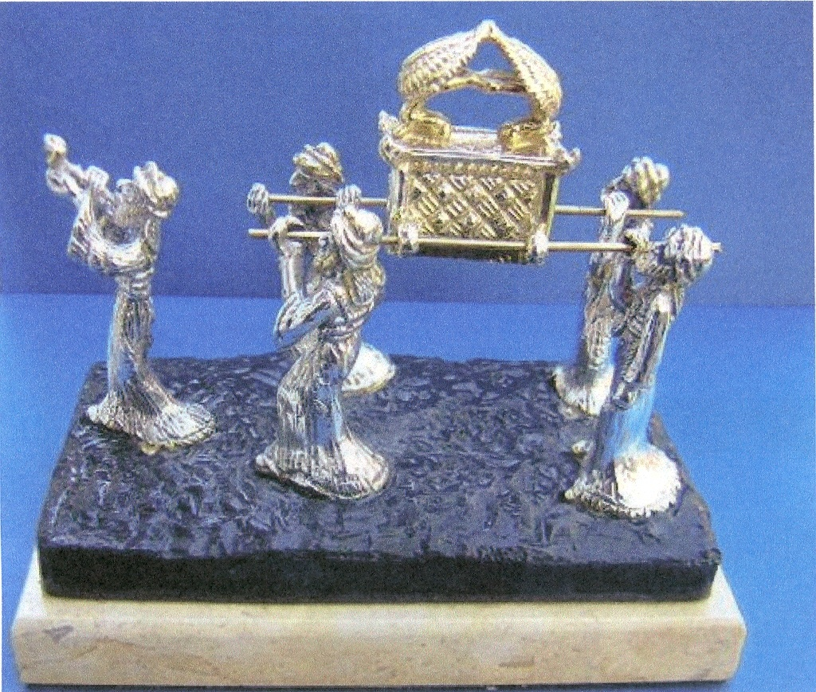
The Ark of the Covenant’s lid was made of gold and had statues of two Cherubim facing one another on it. The lid was called “the mercy seat”. On the Day of Atonement each year the high priest would sprinkle blood on this lid which would postpone God’s judgment of sin until the following year. So this ceremony had to be repeated annually.
When Jesus died on the cross, He became this “mercy seat” for you. ₄₁ To have blood for this event, an animal had to die. ₄₂ In order for Jesus to be this mercy seat, He had to die. When you accept what Lord Jesus did for you on the cross ₄₃ you have to die - to your old life. That’s called repentance. That’s why you are baptized; to demonstrate what’s happening in your life. You symbolize your death to your old life, burial of the old corpse and your resurrection into your new life in Christ. ₄₄
Then, Lord Jesus satisfied the justice of God and at the same time declared you “not guilty”. Verse 26 chimes in here, He did it to demonstrate his justice at the present time, so as to be just and the one who justifies those who have faith in Jesus. “Justify” means being declared “not guilty”. ₄₅
Romans, Chapter 6, verse 23 reminds us that the wages of sin is death. ₄₆ So Jesus died on the cross to pay the wages for your sins. ₄₇ Since those wages have been paid, you don’t have to pay them! ₄₈ So, when you trust Lord Jesus, you don’t experience the consequences of your sins. ₄₉
So, when Lord Jesus says to you, “Hey man, trust Me!”, you can truly trust Him with your life. You can have that right relationship with God. Surrender your life to Him today as Lord!

http://biblelifemessages.org/

Romans 3:21-26.
Uστερέω.
v22 and 24.
Δικαιοσύνη.
Luke 16:26 - And besides all this, between us and you a great chasm has been fixed, so that those who want to go from here to you cannot, nor can anyone cross over from there to us..
v21.
Genesis 22:1-18.
Hebrews 11:19.
Job 1:22.
Aπολύτρωσις.
Iλαστήριον.

