Bible life messages
What Does a Living Sacrifice Involve?
Romans 12:1-2

₁ Christian faith has got to be more than some intellectual belief that there’s a God up there somewhere; that He became a man and died on a cross. ₂ Being a Christian means consecration. Carrying the cross means commitment to it. Lord Jesus said, If anyone would come after me, he must deny himself and take up his cross and follow me. ₃
Romans, Chapter 12, verses 1 and 2 read, Therefore, I urge you, brothers, in view of God’s mercy, to offer your bodies as living sacrifices, holy and pleasing to God — this is your spiritual act of worship. Do not conform any longer to the pattern of this world, but be transformed by the renewing of your mind. Then you will be able to test and approve what God’s will is — his good, pleasing and perfect will.
God demanded animal sacrifices in the Old Testament. An animal was killed as a consequence of sin and presented to God. The animal ended up dead!
God wants sacrifice today from you, but not a dead animal. Instead, He wants a living sacrifice. So, what is a living sacrifice?
I. What is Sacrificed? ₄
What is sacrificed? ₅ It’s not an Old Testament animal blood sacrifice, but your own bodies! ₆
An example of blood sacrifice in the Old Testament was the Day of Atonement found in Leviticus, Chapter 16, verses 2 through 34. The Jews today call this celebration Yom Kipper. ₇
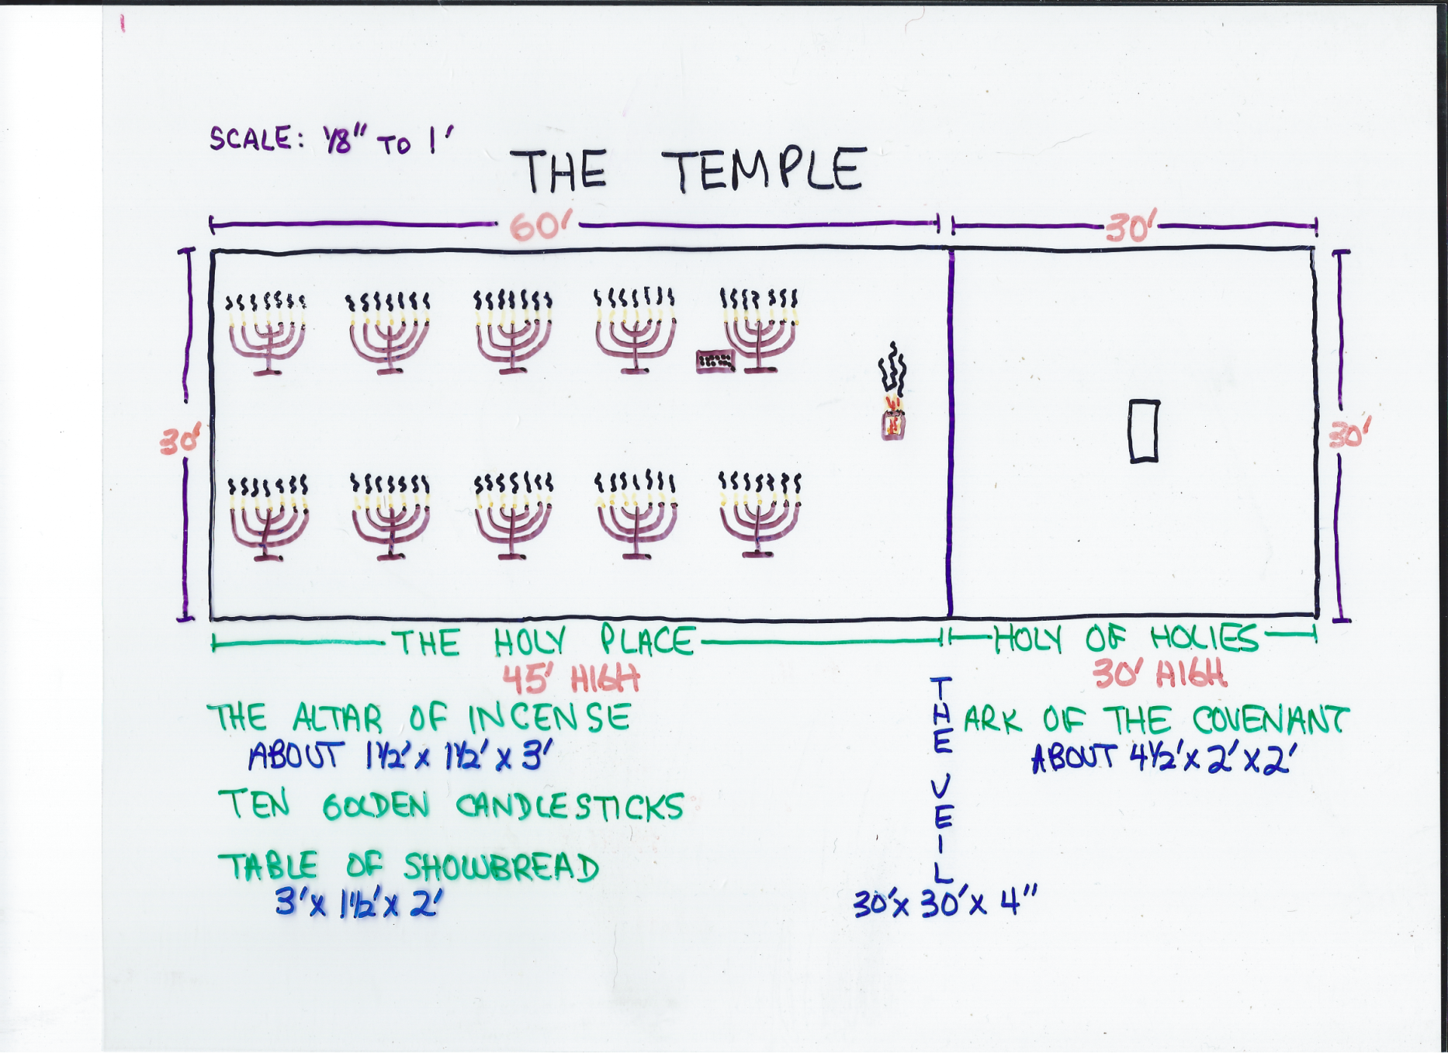
As the people fasted and prayed, the High Priest would kill a bull, walk through the Holy Place, through the veil to the Holy of Holies. ₈ There he would sprinkle the blood from the bull on the golden lid of the Ark of the Covenant to atone for his own sins. ₉ The High Priest would, then, repeat this procedure to atone for the sins of all the people. The final step was to release the “scapegoat” into the wilderness to carry the sins of the people away. ₁₀
An example of God’s unlimited love was demonstrated in the Passover, which the Jews celebrate annually. God rescued the Jews from Egyptian bondage when His death angel passed over the obedient Jews to kill all the firstborn of the disobedient Egyptians. As a result, all the people of God were rescued from Egypt to settle in the Promised Land. Out of gratitude for God’s love to them a special memorial meal was prepared and eaten.
God’s universal expression of His unlimited love to His children, you and me, was when Jesus went to the cross. ₁₁
That event fulfilled the Old Testament era by making Lord Jesus our perfect and permanent High Priest. Hebrews, Chapter 5, verses 5 and 6, So Christ also did not take upon himself the glory of becoming a high priest. But God said to him, “You are my Son; today I have become your Father.” And he says in another place, “You are a priest forever, in the order of Melchizedek.” ₁₂
The cross also made our Lord the perfect blood sacrifice. Colossians, Chapter 1, verses 20 through 22, . . . and through him to reconcile to himself all things, whether things on earth or things in heaven, by making peace through his blood, shed on the cross. Once you were alienated from God and were enemies in your minds because of your evil behavior. But now he has reconciled you by Christ’s physical body through death to present you holy in his sight, without blemish and free from accusation. ₁₃
The final fulfillment was Jesus becoming our perfect scapegoat! John, Chapter 11, verses 49 and 50, record, Then one of them, named Caiaphas, who was high priest that year, spoke up, “You know nothing at all! You do not realize that it is better for you that one man die for the people than that the whole nation perish.”
You see, there was an example of blood sacrifice during the Day of Atonement and an example of God’s unlimited love for His people on the Day of Passover. ₁₄ There also needs to be a Day of Personal Decision for you! Because of the cross, your relationship to the Lord can now become personal. You begin presenting your bodies as a living sacrifice when you surrender your heart to the Lord Jesus! ₁₅
When that happens, you become a priest. First Peter, Chapter 2, verse 5, You also, like living stones, are being built into a spiritual house to be a holy priesthood, offering spiritual sacrifices acceptable to God through Jesus Christ. ₁₆ That’s also when you begin offering your bodies as a living sacrifice. First Corinthians, Chapter 6, verse 13, The body is not meant for sexual immorality, but for the Lord, and the Lord for the body. ₁₇
What does this living sacrifice involve? ₁₈ It’s to be living, not dead. First Corinthians, Chapter 6, verses 19 and 20 states, Do you not know that your body is a temple of the Holy Spirit, who is in you, whom you have received from God? You are not your own; ﻿you were bought at a price. Therefore honor God with your body. ₁₉
It’s to be holy (sacred), not ritualistic. Some can get so wrapped up in tradition and customs that the real thing is distorted. Ritual can interfere with relationships. ₂₀
It’s to be well pleasing to God, not just blind obedience to rules; for instance, obedience to the Law of Moses!

II. Why Make the Sacrifice? ₂₁
God wants you to present your body as a living sacrifice. Why? ₂₂ Verse 1, Therefore, I urge you, brothers, in view of God’s mercy, to offer your bodies as living sacrifices, holy and pleasing to God — this is your spiritual act of worship.
The first reason is because God gave you this opportunity to show your gratitude. ₂₃ This is your response to God showing His mercy, His compassion, to you! ₂₄ This mercy was expressed when Lord Jesus suffered and died on the cross. Where would you be if Jesus had decided not to go to the cross to make this mercy possible? ₂₅
The second reason is because it is your spiritual act of worship. ₂₆ “Spiritual act of worship” means that this is your reasonable, or logical response. ₂₇
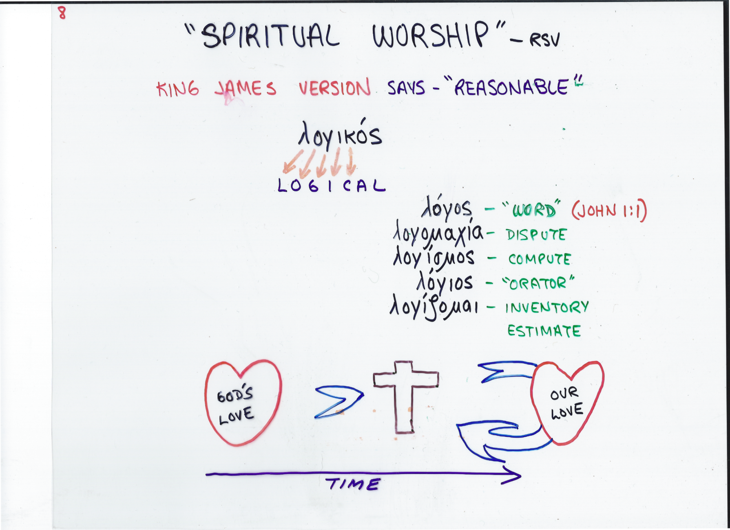
The Revised Standard Version translates this as your “spiritual worship”. The King James Version called it “reasonable”. We get our English word “logical” from this word. Other words in the original language related to this one are translated “word”, “dispute”, “compute”, “orator”, and “inventory estimate”. All of these words convey thinking things out and expressing that idea so that it makes sense. ₂₈
God gave His Only Son for you on the cross. It’s only logical that you give yourself back to God. The world is dying in sin and God’s plan is to use you to introduce it to His saving way! ₂₉ Ephesians, Chapter 5, verse 8 and 10, For you were once darkness, but now you are light in the Lord. Live as children of light ... ﻿and find out what pleases the Lord. ₃₀
The other reason is because your life of obedience can be approved. Verse 2 continues, Do not conform any longer to the pattern of this world, but be transformed by the renewing of your mind. Then you will be able to test and approve what God’s will is — his good, pleasing and perfect will. ₃₁
How can your life be approved if it isn’t seen in action? In James, Chapter 2, we are told that “faith”, “if it is not accompanied by action, is dead”. James says that he will “show you my faith by what I do”! How can your life be seen in action if it isn’t used?

III. How Can I Make This Sacrifice? ₃₂
Now that you know what the living sacrifice is and why you should make it, the next question becomes, how can I make this sacrifice? ₃₃ First Peter, Chapter 1, verses 14 through 16 provide the answer, As obedient children, do not conform to the evil desires you had when you lived in ignorance. But just as he who called you is holy, so be holy in all you do; for it is written: “Be holy, because I am holy.” ₃₄
One thing for sure; it can’t be done by changing yourself outwardly! Notice again what verse 2 says, Do not conform any longer to the pattern of this world. It’s not done by conforming to the world. ₃₅ The word “conform” in the original language means to become a copy of. ₃₆
What does the Bible say about identifying with the world? ₃₇ First John, Chapter 2, verses 15 and 16 says it very potently, Do not love the world or anything in the world. If anyone loves the world, the love of the Father is not in him. For everything in the world — the cravings of sinful man, the lust of his eyes and the boasting of what he has and does — comes not from the Father but from the world. The world is silently crying out for help. They’re lost and dying and many of them know it. They want to see something better than what they have, not something that identifies with it! ₃₈
It must be done by allowing the gospel to transform your mind. ₃₉ The word “transform” in the original language, means to transfigure, to change into another form. ₄₀
We get our word “metamorphosis” from this word. It is a scientific word describing the incredible transformation process of a caterpillar larva, crawling around on a leaf, building its cocoon and then, immerging as a beautiful butterfly moth. ₄₁
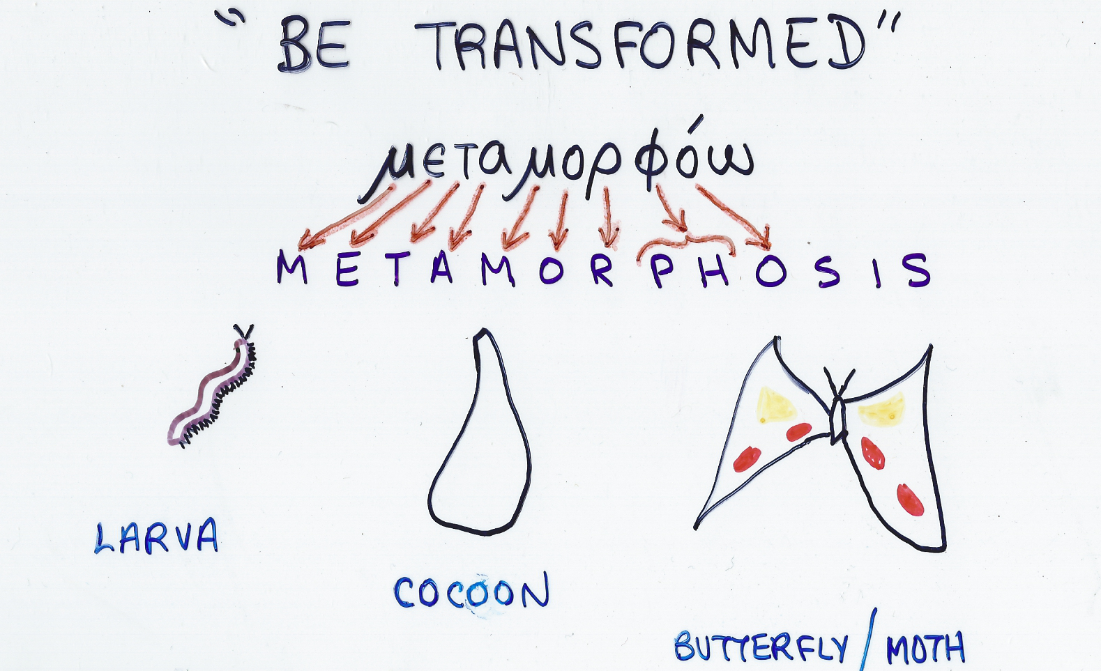
This word is used four times in the New Testament. ₄₂ Here, in verse 2; ₄₃ in Matthew and Mark describing the Lord’s Transfiguration with Moses and Elijah; ₄₄ and in Second Corinthians, Chapter 3, verse 18, in referring to Moses’ veiled face when he came down from Mount Sinai, And we, who with unveiled faces all reflect the Lord’s glory, are being transformed into his likeness with ever-increasing glory, which comes from the Lord, who is the Spirit. ₄₅
These changes begin to take place when you renew your mind. ₄₆
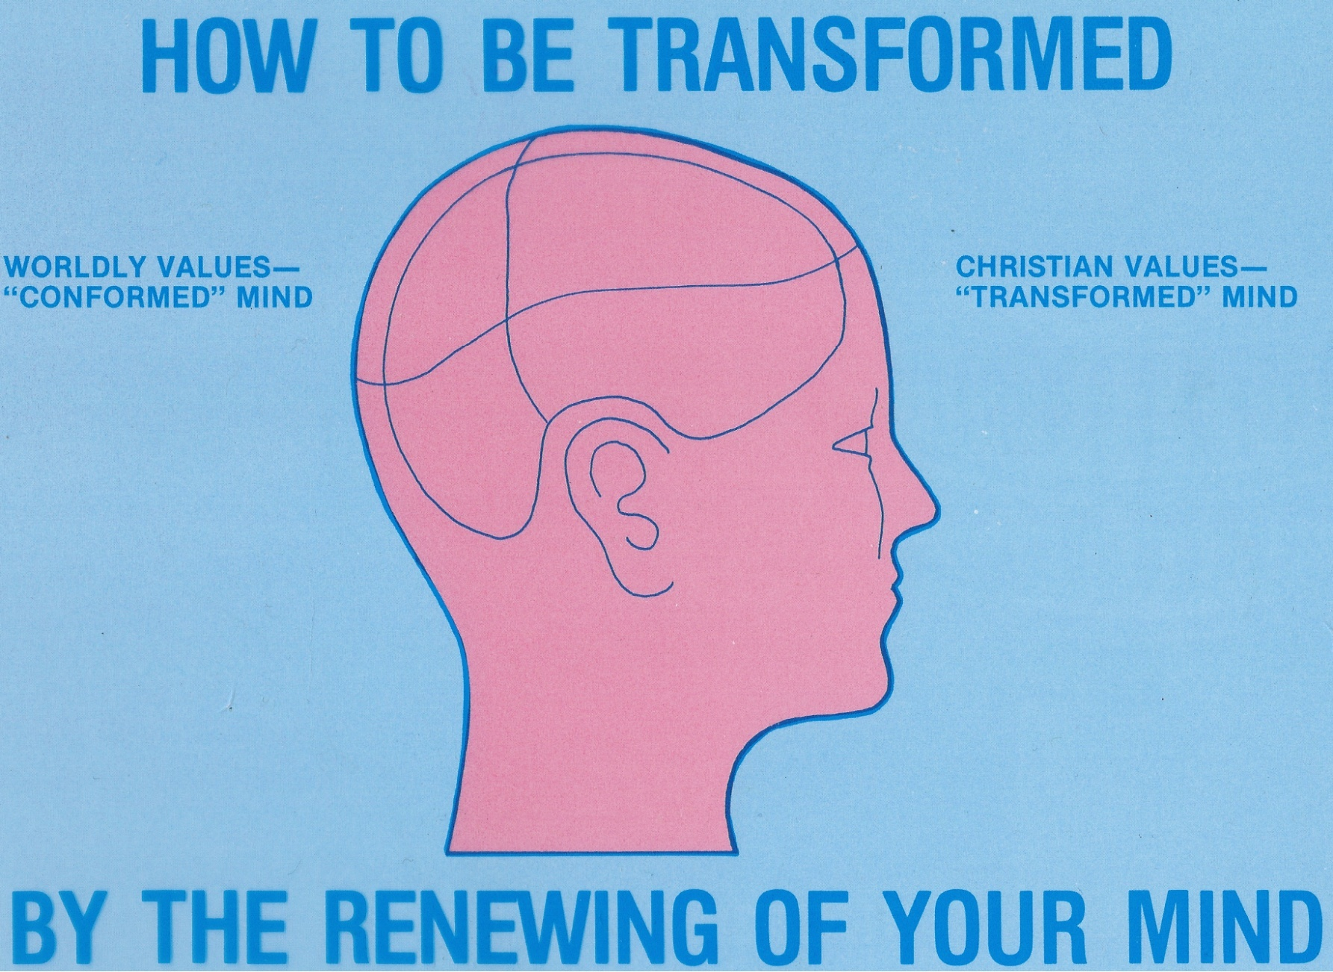
To renew your mind means to change your purposes in life to God’s values, His purposes for you. ₄₇ God’s eager desire for you is that the eyes of your heart may be enlightened in order that you may know the hope to which he has called you, the riches of his glorious inheritance in the saints . . . ₄₈
God has called you to “offer your bodies as a living sacrifice”. He wants you to take up your cross and follow Him. It’s a life of challenge. It’s a life of commitment. When you do, you find the victorious life; the life God planned for you to have!

http://biblelifemessages.org/

Matthew 16:24.
Leviticus 16:6 - Aaron is to offer the bull for his own sin offering to make atonement for himself and his household.
Leviticus 16: 15, 21-22.
v1.
Οiκτιρμός.
τὴν λογικὴν λατρείαν ὑμω̂ν.
From John 1:1 - In the beginning was the Word, and the Word was with God, and the Word was God.
James 2:14-18.
Συσχηματίζω.
Μεταμορφόω.
Matthew 17:2 and Mark 9:2.
Ephesians 1:18.
Matthew 16:24.

