|  |
| --- |
| **Bible life messages** |
| How is Spiritual Fruit Produced in Your Life? |
| John 15:1-11 |
|  |
|  |
|  |

|  |
| --- |
|  |

**1 How is spiritual fruit produced in your life? Let's look at the Gospel of John, Chapter 15, verses 1 through 11 to find out. 2 I am the true vine, and my Father is the gardener. He cuts off every branch in me that bears no fruit, while every branch that does bear fruit he prunes so that it will be even more fruitful. You are already clean because of the word I have spoken to you. Remain in me, and I will remain in you. No branch can bear fruit by itself; it must remain in the vine. Neither can you bear fruit unless you remain in me. 3**

**I am the vine; you are the branches. If a man remains in me and I in him, he will bear much fruit; apart from me you can do nothing. If anyone does not remain in me, he is like a branch that is thrown away and withers; such branches are picked up, thrown into the fire and burned. If you remain in me and my words remain in you, ask whatever you wish, and it will be given you. This is to my Father’s glory, that you bear much fruit, showing yourselves to be my disciples. 4**

**As the Father has loved me, so have I loved you. Now remain in my love. If you obey my commands, you will remain in my love, just as I have obeyed my Father’s commands and remain in his love. I have told you this so that my joy may be in you and that your joy may be complete.**

**Are you living a fruitful, victorious, abundant life in Christ? That is the type of life the Lord expects you to have as you surrender your life to His authority. Your life can be dramatically and wonderfully different when it is filled and controlled by His Spirit. 5**

**The Bible shows a Christian's relationship to the world like a grafted branch's relationship to the vine to which it is attached.**

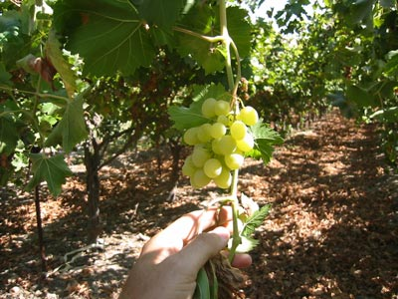

**September is grape harvest time in Northern California where we used to live. As an Army Reservist, I would take my two weeks of summer active-duty training at Fort Hunter-Leggett. Traveling there I would observe along the road miles and miles of grapes close to being ready for harvest. The vines were just loaded with them! In jungles, grape vines even climb and intertwine with the trees hiding the sun from the ground.**

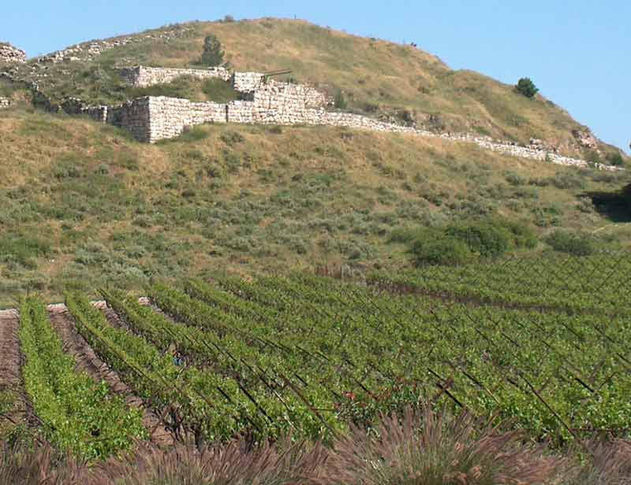

**In Israel today there are vineyards all over the country, nearly everywhere. These vines produce two kinds of branches: fruit bearing and non fruit bearing. Since the wood of the branch isn't really good for anything, non fruit bearing branches are pruned and burned to conserve the nourishment of the vine stock. 6 So, a branch must either remain connected to the vine, or be grafted in, to produce grapes! If it is pruned because it is not bearing fruit, it is good for nothing and burned. 7**

**The first question in helping us to understand this scripture is . . .**

**I. What is the Symbolism of the Vine?**

**What is the symbolism of the vine? 8 The vine was the symbol of Israel. It appeared on Maccabean [1] coins and on the front of the Jewish Temple. 9**



**In verse 1 the Lord claimed to be the root vine stock. [2] 10 He was the vine planted by God. Matthew, Chapter 1, verse 20, But after he had considered this, an angel of the Lord appeared to him in a dream and said, “Joseph son of David, do not be afraid to take Mary home as your wife, because what is conceived in her is from the Holy Spirit”. 11 He was the vine cared for by the God by being nourished by the angels after His temptation [3] and passing through the crowd at Nazareth [4]. 12**

**Who are the branches? 13 Verse 5 [5] says you are the branches! 14 The Jews were the original branches, but they didn't produce [6]. So Christians, you and me, took their place. 15 But verse 4 [7] says you must be attached to be fruitful! 16**

**What is the graft that binds you to the vine? Normally a branch is grafted to a wine stock with grafting wax or paraffin. 17**

**Verse 9 tells us that the spiritual grafting wax is love. [8] 18 The Father loved the Son. John, Chapter 17, verse 26, I have made you known to them, and will continue to make you known in order that the love you have for me may be in them and that I myself may be in them. 19 The Son loved you enough to go to the cross [9]. 20 You need to reflect that love to others, even your enemies! [10] 21**

**Verse 10 tells us that the spiritual grafting wax is obedience. [11] In First John, Chapter 3, verse 24, it reads, Those who obey his commands live in him, and he in them. And this is how we know that he lives in us: We know it by the Spirit he gave us. You find what He wants you to do in His Word, the Bible. Then, whatever you find the Lord wants you to do, do it! 22**

**Then, verse 11 tells us that the spiritual grafting wax is joy. [12] 23 The Ethiopian, in Acts, Chapter 8, went on his way rejoicing. [13] 24 The disciples, in Acts, Chapter 5, rejoiced at the privilege of being persecuted for the Lord. [14]**

**The second question in helping us to understand this scripture is . . . 25**

**II. What Does It Mean to Remain in Christ?**

**What does it mean to remain in Christ? 26 The word "remain", in the original language [15] means "to abide", "to live in", "to continue to be present in" or "to endure". It can also mean "to wait for". 27 You are responsible, then, to remain in the Lord's love [16], 28 not to fall away [17], 29 not to abandon the faith [18] 30 and to bear spiritual fruit. [19] 31**

**How do you remain in Christ? 32 Ephesians, Chapter 3, verse 17 [20] tells us by trusting, or having faith, that He is dwelling in your heart. 33 First John, Chapter 2, verse 6, [21] tells us it is by walking, conducting yourself, the way Lord Jesus conducted Himself. 34 Then, in Second John, verse 9 [22] it's by continuing in biblical teaching. It is important what you believe!**

**The third question in helping us understand this scripture is . . . 35**

**III. If You Remain in Christ - What Will Happen?**

**If you remain in Christ, what will happen? 36 Notice verses 2 and 3, He cuts off every branch in me that bears no fruit, while every branch that does bear fruit he prunes so that it will be even more fruitful. You are already clean because of the word I have spoken to you. He will clean you up. 37 The word "prune" [23] means to "cut off" or "clean". A related word in the original language is this word "clean" [24] which means "to become clean", "pure" or "ritually innocent". 38 Absorbing the Word of God in your brain makes you different! 39**

**Another thing that will happen is found in verse 4, Remain in me, and I will remain in you. He will remain in you. 40 The Lord really is in you as "the hope of glory" [25]. 41 He dwells in you through the indwelling of the Holy Spirit which is promised to you [26]. John, Chapter 14, verse 17, states, . . . the Spirit of truth. The world cannot accept him, because it neither sees him nor knows him. But you know him, for he lives with you and will be in you. 42 Because the Lord is living in you, your spirit is alive even though your body is decaying [27]. Galatians, Chapter 5, verses 20 emphasizes, I have been crucified with Christ and I no longer live, but Christ lives in me. 43**

**Another thing that will happen is found in verse 4 and 5, No branch can bear fruit by itself; it must remain in the vine. Neither can you bear fruit unless you remain in me. I am the vine; you are the branches. If a man remains in me and I in him, he will bear much fruit; apart from me you can do nothing. So, you will bear much fruit. 44 Verse 8 tells us that bearing fruit honors the Father and presents you as a true disciple [28]. 45**

**So, what's the fruit? 46 It's your character. The indwelling Holy Spirit is producing His fruit in you! Galatians, Chapter 5, verses 22 and 23 point out, . . . the fruit of the Spirit is love, joy, peace, patience, kindness, goodness, faithfulness, gentleness and self-control. Against such things there is no law. 47 This could also imply lost souls for the kingdom of God harvested because of your witness to them. 48**

**Another thing that will happen is found in verse 7. It tells us that you will have an effective prayer life: If you remain in me and my words remain in you, ask whatever you wish, and it will be given you. 49**

**The final thing that will happen is in First John, Chapter 2, verse 28, And now, dear children, continue in him, so that when he appears we may be confident and unashamed before him at his coming. 50**

**It's your responsibility to remain connected to the Lord. Your personal relationship with Him will give you the purpose and meaning in your life He created for you to have!**

**biblelifemessages.org**

1. **The period between the Old Testament and the New Testament in our Bibles. Israel had gained independence from foreign occupation.**
2. **v1 - I am the true vine . . .**
3. **Matthew 4:11 - Then the devil left him, and angels came and attended him.**
4. **Luke 4:29-30 - They got up, drove him out of the town, and took him to the brow of the hill on which the town was built, in order to throw him down the cliff. But he walked right through the crowd and went on his way.**
5. **v5 - I am the vine; you are the branches.**
6. **Isaiah 5:1-7; Jeremiah 2:21; Hosea 10:1 and Psalm 80:8.**
7. **v4 - . . . No branch can bear fruit by itself; it must remain in the vine.**
8. **v9 - As the Father has loved me, so have I loved you. Now remain in my love.**
9. **John 3:16 - For God so loved the world that he gave his one and only Son . . .**
10. **Matthew 5:44- But I tell you: Love your enemies and pray for those who persecute you.**
11. **v10 - If you obey my commands, you will remain in my love, just as I have obeyed my Father’s commands and remain in his love.**
12. **v11 - I have told you this so that my joy may be in you and that your joy may be complete.**
13. **Acts 8:39 - When they came up out of the water, the Spirit of the Lord suddenly took Philip away, and the eunuch did not see him again, but went on his way rejoicing.**
14. **Acts 5:41 - The apostles left the Sanhedrin, rejoicing because they had been counted worthy of suffering disgrace for the Name.**
15. **μένω.**
16. **v9 - . . . remain in my love . . .**
17. **Hebrews 6:4-6 - It is impossible for those who have once been enlightened, who have tasted the heavenly gift, who have shared in the Holy Spirit, who have tasted the goodness of the word of God and the powers of the coming age, if they fall away, to be brought back to repentance, because to their loss they are crucifying the Son of God all over again and subjecting him to public disgrace.**
18. **I Timothy 4:1 - The Spirit clearly says that in later times some will abandon the faith and follow deceiving spirits and things taught by demons.**
19. **v2-3 - He cuts off every branch in me that bears no fruit, while every branch that does bear fruit he prunes so that it will be even more fruitful. Remain in me, and I will remain in you. No branch can bear fruit by itself; it must remain in the vine. Neither can you bear fruit unless you remain in me.**
20. **Ephesians 3:17 - I pray that out of his glorious riches he may strengthen you with power through his Spirit in your inner being, so that Christ may dwell in your hearts through faith.**
21. **I John 2:6 - Whoever claims to live in him must walk as Jesus did.**
22. **II John 9 - Anyone who runs ahead and does not continue in the teaching of Christ does not have God; whoever continues in the teaching has both the Father and the Son.**
23. **καθαίρω.**
24. **καθαρός.**
25. **Colossians 1:27 - . . . the hope of glory . . .** 
26. **Acts 2:38 - Peter replied, “Repent and be baptized, every one of you, in the name of Jesus Christ for the forgiveness of your sins. And you will receive the gift of the Holy Spirit.**
27. **Romans 8:10-11 - But if Christ is in you, your body is dead because of sin, yet your spirit is alive because of righteousness. And if the Spirit of him who raised Jesus from the dead is living in you, he who raised Christ from the dead will also give life to your mortal bodies through his Spirit, who lives in you.**
28. **v8 - This is to my Father’s glory, that you bear much fruit, showing yourselves to be my disciples.**